Dear Bulldog Parents and Guardians—

Holley Navarre Middle School

World History

 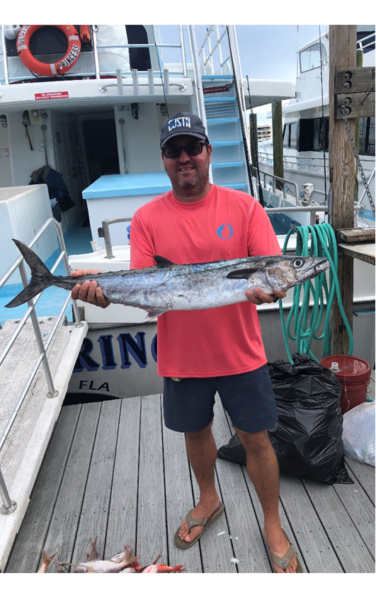

Welcome to Holley Navarre Middle School--6th Grade World History and 8th Grade U.S. History. 6th grade is an exciting time as students embark upon new adventures in middle school. Our 8th grade students are completing their last year before venturing into the gigantic world of high school. This year promises to be an interesting one for all of us. By working together, we can make this an awesome experience for everyone. I look forward to meeting your family, celebrating special events together, and creating a year that you will never forget.

**Rules—**

I retired from the U.S. Air Force JAG Corps. I live by checklists. I love rules. However, I’m not 11 years old.

We are going to keep it simple. In order to have an amazing year, we are going to follow the three R’s:

* Be **READY**
* Be **RESPONSIBLE**
* Be **RESPECTFUL**

**READY**: In our classroom, you are ready for class when:

* You have a sharpened pencil and your history notebook on your table in front of you as soon as you sit down.
* You should have one notebook or folder for each class. Doing this will help keep you from losing your work.
* You have your assigned work ready to turn in with your name and class period written at the top.
* You have your Bulldog Planner with you **EVERY DAY**. You will use it to write down assignments and due dates, as well as signing out of class to use the restroom.

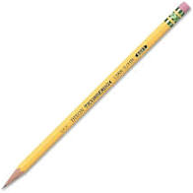 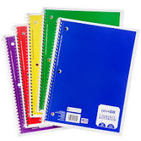 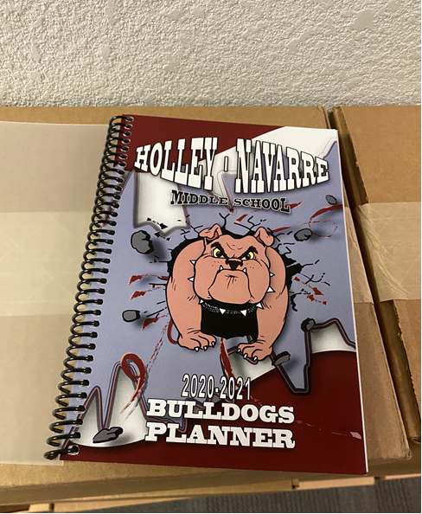

**RESPONSIBLE:**

* When you need to use the restroom, you will fill your planner out; hand it to me to sign; sign out and back in on the sign out log as you leave the room. No one needs to know that you have to go to the bathroom, so don’t announce it to the class. Quietly fill out the planner and take care of business.
* *NOTE:* Please do not leave the room during the first or last 10 minutes of class unless it is an emergency. “Emergencies” should be very rare.
* You will copy assignments and their due dates into your planner **every day**. Not only does this help you focus on what we are learning, it helps your parents/guardians to know what our major learning goals are. Finally, you will have a **planner check** once per quarter and if you have written down each day’s objective, you will get a very easy 100%.

If you are like me, you know you are going to be asked, “What did you learn in school today?”. This is how you answer that question—“Today’s assignment was…(show them your planner).

* I am not your mom. She’s probably nicer than I am. I don’t leave trash in your room. Don’t leave trash in ours.

**RESPECTFUL:**

* We don’t use profanity in our classroom. We also don’t use words that hurt people based on their color, religion, disabilities, or who they love. I will warn you once about abusive words toward others. If it happens again, I will contact your parent/guardian. You are uniquely gifted so you know how to treat others around you.
* **Cell phones are not allowed on campus. If I see your cell phone, I will confiscate it and turn it over to a member of the administrative team.**
* We all have interesting things to say, but we can’t say them at the same time. Raise your hand and wait for me to call on you. If I am talking to the whole class, you should not be talking.
* Just because you can, doesn’t mean you should.

**SUPPLIES:**

Each student will need to have the following materials for class every day:

* Pencils or Pens (if using a mechanical pencil please have your own lead)

It’s ok NOT to share.

* Highlighters—some people don’t share well with others (like your history teacher). Please bring your own.
* A history notebook (as shown above). Do not use the folders with pockets as your history notebook—you will lose almost everything if you use these. Three ring binders are fine to use as history notebooks.

It’s ok NOT to share.

* Notebook paper (if you are using a history notebook, you don’t need loose paper in addition)
* Colored pencils, markers, rulers, and scissors. The more **you** bring, the less you have to share.

**MR. MEEKER’S WISH LIST:** Copy paper**,** highlighters, disinfecting wipes, hand sanitizer, Kleenex, 3x5 index cards, dry erase markers, a Penn surf rod/reel combo (just kidding, maybe)

**GRADING POLICY**:

A. Grading Scale: 90-100 A, 80-89 B, 70-79 C, 60-69 D, 59 and below F.

B. Grades will be based on the following categories and weighting:

**Minor:** 25% (bell work, homework, and participation) **Intermediate**: 35% (quizzes, classwork) **Major**: 40% (tests, projects)

C. All work must be legible and have the student’s **FULL FIRST AND LAST NAME** written on it. After the first month of school, **if an assignment is submitted without a first and last name, it will be thrown away and the student will earn a 0.**

**Late Work**: You are expected to turn in your work on the assigned due date. Late work without an approved absence excusal will be accepted for up to 3 school days after the due date, but the following penalties will be applied:

1 day late = minus 25% 2 days late = minus 50 % 3 days late = minus 75% 4 days or more late—Not accepted

**Parents/Guardians:**

Thank you for everything that you do to make your child such a valuable, irreplaceable part of this team. It is an honor to be able to work with them. If you need anything or have any questions or concerns, please don’t hesitate to contact me.

Brian Meeker, HNMS History [MeekerB@santarosa.k12.fl.us](mailto:MeekerB@santarosa.k12.fl.us)

---------------------------------------------------------------------------------------------------------------------------------------------------

Please sign below, indicating that you and your child have read and discussed the information above. Once the section below is signed, please have your student return this letter to class—it will be their first graded assignment.

Student (printed) __________________________ **Class Period #**_______ Student (signed)______________________

Parent/Guardian (printed) ____________________ Parent/Guardian (signed)________________